Sept. 10, 2017
Dear Donor,
We all need help sometimes: after the birth of a child, when a loved one falls ill, during a time of unemployment. Sometimes we can rely upon our family and friends to see us through, sometimes we can’t.
It is in these times that we must reach out to our community and trust that others will reach back. Capital Area United Way creates the space where those hands meet.
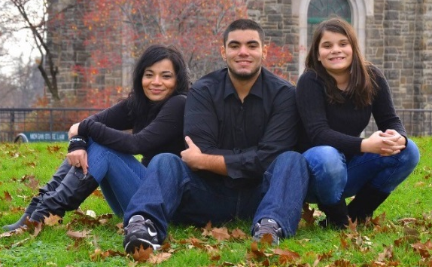
Your support of United Way helps families like Luci’s, seen here. There were times, pregnant and homeless, when she lived out of her car, parking in an all-night car wash for protection and privacy. There are times when Luci agonized over spending her last $20 bill on food or on electricity. Like so many others, Luci had the will to become self-sufficient but she needed help getting there. Thankfully, Luci was guided to Central Michigan 2-1-1, United Way’s 24-hour referral line – where she was connected to a network of programs locally that helped her build a life beyond crisis. Today, Luci has a successful career and is the proud mother of two children who are excelling in school. They are benefitting from the power of YOUR gift…and now they give back as well. Through volunteerism, presentations on United Way and their own donations, this family moved from needing help to giving help. A success story because of YOU.
“Not only did United Way help me with resources but they helped me with words of hope…telling me everything was going to be okay. Thankfully it was. I hope you join me this year in supporting Capital Area United Way and giving people similar to me the opportunities I received and the chance to know that there’s hope.” - Luci Solis

More than 90,000 tri-county residents like Luci and her children were helped last year alone by 14,000+ United Way donors and volunteers just like you. Those neighbors were provided food and clothing, free tax preparation assistance, budgeting help, medical services and dozens of other resources to get them back on their feet and away from crisis. You have the power to be a hero to families like Luci’s. Please make a gift today for these 90,000 reasons.
Respectfully,
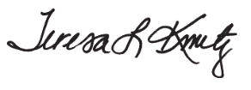

Sam Clark, President/CEO Teresa L. Kmetz
Clark Construction Company President/CEO

